University of Canberra
Faculty of Science and Technology

Software Technology 2
(7170)
Week 8 Tutorial & Computer Lab

Assignment 1: Individual Project
Part 5: Graph Data Structure and Algorithms in Python

Learning Objectives
- Understand graph representation using adjacency lists.
- Implement basic graph operations: add/remove vertices and edges.
- Apply BFS and DFS algorithms for traversal.
- Detect cycles in undirected graphs.
- Build a small visualization with Tkinter.
- Benchmark graph operations.
Outline of Tasks
Task | Concept | Key Points
1 | Graph Structure & Modification | Adding/removing vertices & edges
2 | BFS Traversal | Level-order visiting using queue
3 | DFS Traversal | Depth-first visiting using stack
4 | Cycle Detection | Recursion to detect cycles in undirected graphs
5 | Directed & Weighted Graphs | Handling edge direction and weights
6 | Visualization | GUI display
7 | Benchmarking | Performance testing
8 | Challenge Task | Extended Graph Visualiser

Task 1: Implement and Extend Graph Basics
Goal: Practice adding/removing vertices and edges.
- Create a Graph class in module graph.py
- Import the Graph class for and create Task 1 module (graph_tester.py )
- Add vertices A, B, C, D.
- Add edges between them, both directed and undirected (test both versions).
- Remove a vertex and an edge.
- Print the graph after each operation to observe changes.
- Outcome: Understand graph representation and basic modifications.
#===graph.py===
class Graph:
def __init__(self, directed=False, weighted=False):
self.graph = {} # Initialize an empty dictionary to store the adjacency list
self.weights = {}
self.directed = directed
self.weighted = weighted

def add_vertex(self, vertex):
if vertex not in self.graph:
self.graph[vertex] = [] # Add a new vertex with an empty list of edges

def add_edge(self, vertex1, vertex2, weight=0):
if vertex1 in self.graph and vertex2 in self.graph: # Check that vertices are present
# store vertex and weight as a tuple
self.graph[vertex1].append(vertex2)
if self.weighted:
self.weights[(vertex1, vertex2)] = weight
if not self.directed: # In the case of an undirected graph, append in both directions
self.graph[vertex2].append(vertex1)
if self.weighted:
self.weights[(vertex2, vertex1)] = weight
else:
print("One or both vertices not found in graph.")

#===graph_tester.py===
from graph import Graph
#Basic undirected graph tests
g = Graph()
g.add_vertex('A')
g.add_vertex('B')
g.add_vertex('C')

g.add_edge('A', 'B')
g.add_edge('B', 'C')

g.print_graph()
print()

# Directed graph tests
g = Graph(directed=True)
g.add_vertex('A')
g.add_vertex('B')
g.add_vertex('C')

g.add_edge('A', 'B')
g.add_edge('B', 'C')

g.print_graph()
print()

# Weighted graph tests
g = Graph(weighted=True, directed=True)
g.add_vertex('A')
g.add_vertex('B')
g.add_vertex('C')

g.add_edge('A', 'B', 15)
g.add_edge('B', 'C', 34)

g.print_graph()

# Removal tests
print()
print("Removal test")
removal_test = Graph()
removal_test.add_vertex('A')
removal_test.add_vertex('B')
removal_test.add_vertex('C')

removal_test.add_edge('A', 'B')
removal_test.add_edge('B', 'C')

removal_test.print_graph()

removal_test.remove_edge('A', 'B')

removal_test.print_graph()

removal_test.remove_vertex('C')

removal_test.print_graph()
print()
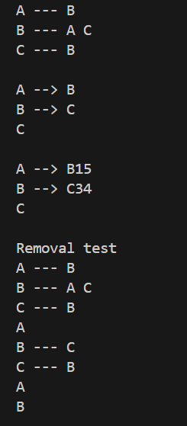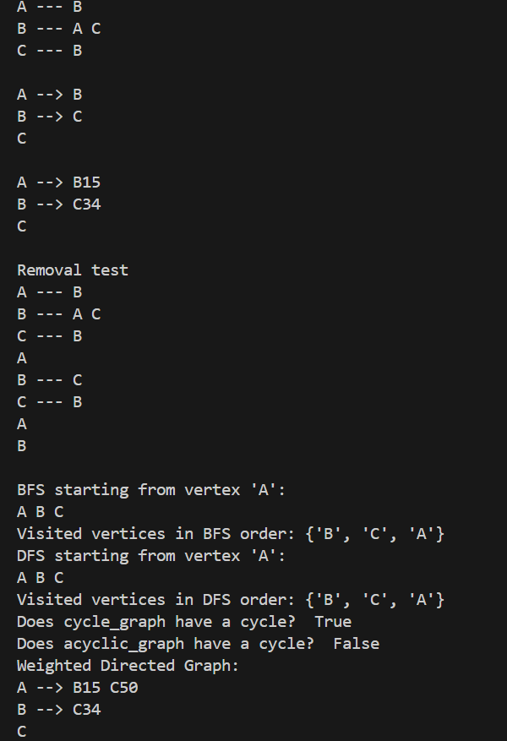

Task 2: Breadth First Search (BFS) Implementation
Goal: Explore graph traversal using BFS.
- Implement BFS starting from a given vertex.
- Add the following code to graph_tester.py to implement BFS algorithm
- Print the order of visited vertices.
- Test with a small graph (A → B → C and additional connections).
- Discuss BFS properties (level-by-level exploration).
- Outcome: Grasp BFS logic and its applications.
# BFS on the graph from Activity 1
print("BFS starting from vertex 'A':")
visited_bfs = g.bfs('A')
print("Visited vertices in BFS order:", visited_bfs)

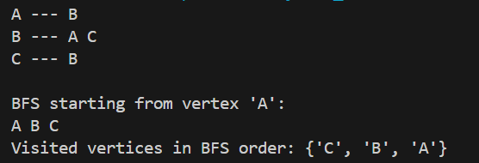

Task 3: Depth First Search (DFS) Implementation
Goal: Understand DFS differences and practice stack-based traversal.
- Implement DFS using a stack (already provided).
- Add the following code to graph_tester.py to implement DFS algorithm
- Compare output order with BFS on same graph.
- Test on branched graph including cycles.
- Outcome: Compare traversal techniques; understand search strategies.
# DFS on the same graph
print("DFS starting from vertex 'A':")
visited_dfs = g.dfs('A')
print("Visited vertices in DFS order:", visited_dfs)

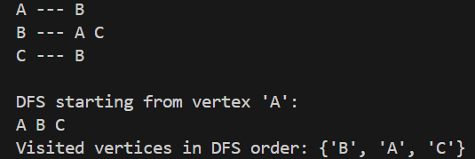

Task 4: Cycle Detection in Undirected Graphs
Goal: Write and test code to detect cycles using DFS recursion.
- Create graphs with and without cycles (triangle graph and linear chain).
- Add the following code to graph_tester.py to implement Cycle Detection algorithm in Undirectred Graphs
- Verify correct detection with boolean output.
- Outcome: Learn how DFS can detect cycles and why this matters.
#cycle detection in undirected graphs
# Create graph with a cycle
cycle_graph = Graph(directed=False)
for v in ['A', 'B', 'C']:
cycle_graph.add_vertex(v)
cycle_graph.add_edge('A', 'B')
cycle_graph.add_edge('B', 'C')
cycle_graph.add_edge('C', 'A') # Closing the cycle

print("Does cycle_graph have a cycle? ", cycle_graph.has_undirected_cycle())

# Create graph without a cycle
acyclic_graph = Graph(directed=False)
for v in ['X', 'Y', 'Z']:
acyclic_graph.add_vertex(v)
acyclic_graph.add_edge('X', 'Y')
acyclic_graph.add_edge('Y', 'Z')
print("Does acyclic_graph have a cycle? ", acyclic_graph.has_undirected_cycle())
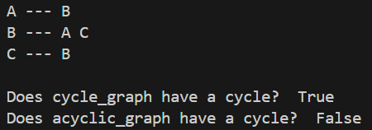

Task 5: Experiment with Weighted and Directed Graphs
Goal: Practice using weighted edges and directed graphs.
- Create a weighted directed graph with given weights.
- Add the following code to graph_tester.py to implement Weighted and Directed Graphs
- Add edges with weights (e.g., A → B with 15, B → C with 34).
- Print graph showing weights.
- Discuss how weights affect graph operations.
- Outcome: Understand storing and using edge weights.
# Create weighted directed graph
wg = Graph(directed=True, weighted=True)
for v in ['A', 'B', 'C']:
wg.add_vertex(v)
wg.add_edge('A', 'B', weight=15)
wg.add_edge('B', 'C', weight=34)
wg.add_edge('A', 'C', weight=50)
print("Weighted Directed Graph:")
wg.print_graph()

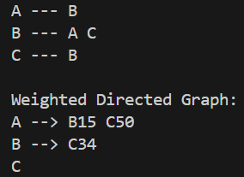

Task 6: Visualization Graph Data Structure with Tkinter
- Use Tkinter to create a simple GUI window.
- Display vertices as circles and edges as lines/arrows in a canvas.
- Implement buttons for adding/removing vertices/edges.
- Highlight BFS or DFS traversal order dynamically.
- Optional: Display edge weights near edges.
- Create a new python module (graph_visualizer.py ) and import Graph class from graph.py
# === graph_visualizer.py ===
from graph import Graph
import tkinter as tk

class GraphVisualizer(tk.Tk):
def __init__(self, graph):
super().__init__()
self.title("Graph Visualizer")
self.graph = graph
self.canvas = tk.Canvas(self, width=400, height=400, bg='white')
self.canvas.pack()
self.vertex_positions = {}
self.draw_graph()

def draw_graph(self):
self.canvas.delete("all")
radius = 20
spacing = 100
# Arrange vertices in a circle
n = len(self.graph.graph)
angle_gap = 360 / n if n else 0
center_x, center_y = 200, 200
for i, v in enumerate(self.graph.graph):
angle = i * angle_gap
x = center_x + spacing * tk.math.cos(tk.math.radians(angle))
y = center_y + spacing * tk.math.sin(tk.math.radians(angle))
self.vertex_positions[v] = (x, y)
self.canvas.create_oval(x - radius, y - radius, x + radius, y + radius, fill='lightblue')
self.canvas.create_text(x, y, text=v)

# Draw edges
for v in self.graph.graph:
x1, y1 = self.vertex_positions[v]
for nbr in self.graph.graph[v]:
x2, y2 = self.vertex_positions[nbr]
self.canvas.create_line(x1, y1, x2, y2, arrow=tk.LAST if self.graph.directed else None)
if self.graph.weighted:
w = self.graph.weights.get((v, nbr), '')
mid_x, mid_y = (x1 + x2) / 2, (y1 + y2) / 2
self.canvas.create_text(mid_x, mid_y, text=str(w), fill="red")

if __name__ == "__main__":
g = Graph(directed=True, weighted=True)
g.add_vertex('A')
g.add_vertex('B')
g.add_vertex('C')
g.add_edge('A', 'B', 10)
g.add_edge('B', 'C', 20)
g.add_edge('C', 'A', 30)

app = GraphVisualizer(g)
app.mainloop()
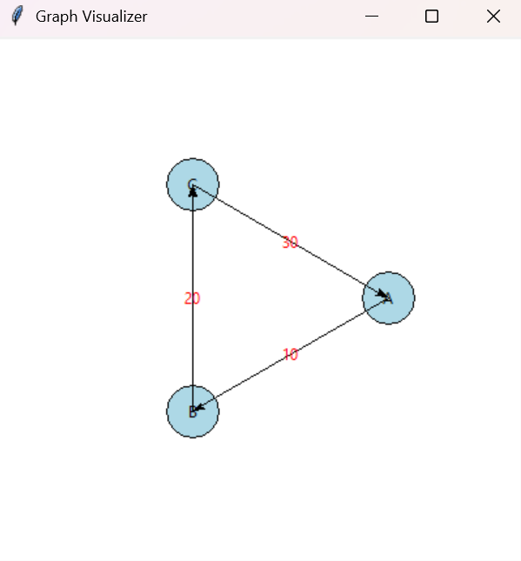

Task 7: Benchmarking Graph Operations
- Create graphs of increasing sizes (e.g., 10, 100, 1000 vertices).
- Time execution of adding vertices, adding edges, BFS, DFS.
- Print or display benchmarking results in console or GUI.
- Discuss performance implications of graph size and structure.
- Create a new python module (graph_benchmarking.py ) and import Graph class from graph.py
#===graph_benchmarking.py===
from graph import Graph
import time

def benchmark_graph_operations(num_vertices, num_edges):
g = Graph()
start_time = time.time()
for i in range(num_vertices):
g.add_vertex(str(i))
vertex_time = time.time()
print(f"Added {num_vertices} vertices in {vertex_time - start_time:.4f} seconds")

import random
edges_added = 0
for _ in range(num_edges):
v1 = str(random.randint(0, num_vertices -1))
v2 = str(random.randint(0, num_vertices -1))
if v1 != v2:
g.add_edge(v1, v2)
edges_added += 1
edge_time = time.time()
print(f"Added {edges_added} edges in {edge_time - vertex_time:.4f} seconds")

# BFS from vertex '0' if exists
if '0' in g.graph:
bfs_start = time.time()
g.bfs('0')
bfs_time = time.time()
print(f"BFS completed in {bfs_time - bfs_start:.4f} seconds")
else:
print("Vertex '0' not found for BFS")

if __name__ == "__main__":
benchmark_graph_operations(num_vertices=1000, num_edges=3000)

VERTICES 10:
Added 10 vertices in 0.0000 seconds
Added 2679 edges in 0.0056 seconds
0 4 5 6 1 7 2 9 3 8
BFS completed in 0.0002 seconds

VERTICES 100:
Added 100 vertices in 0.0000 seconds
Added 2981 edges in 0.0046 seconds
0 51 47 35 30 81 14 79 94 41 26 65 62 6 61 97 5 45 80 24 72 42 59 82 20 37 84 85 56 71 77 7 66 34 78 49 57 8 64 52 96 36 73 83 87 25 95 54 92 43 15 27 19 16 93 2 22 17 21 12 55 44 23 67 39 32 89 76 98 4 33 48 68 88 11 1 31 75 60 3 10 53 91 18 46 69 74 50 86 58 99 90 63 40 70 9 28 13 38 29
BFS completed in 0.0003 seconds
VERTICES 1000:
Added 1000 vertices in 0.0002 seconds
Added 2994 edges in 0.0052 seconds
0 381 737 254 662 592 459 286 64 319 678 696 136 712 417 764 401 687 415 512 237 723 628 613 311 446 965 995 283 889 805 35 728 617 174 770 379 97 289 131 479 856 786 182 565 247 292 726 647 441 200 210 744 332 24 541 305 583 278 474 453 205 15 428 983 632 107 172 113 209 839 554 489 375 496 903 280 724 880 386 918 101 917 480 695 60 763 875 718 552 360 970 271 759 919 48 667 521 824 943 45 75 418 198 669 531 654 2 201 532 366 638 166 408 634 906 175 376 807 973 470 315 702 14 921 177 167 378 646 100 936 195 799 610 383 590 486 93 134 153 657 488 900 309 371 443 478 361 284 429 609 844 795 913 224 238 934 141 611 313 452 797 892 847 506 597 834 475 569 333 490 683 6 331 33 396 802 835 54 306 661 76 596 267 454 405 680 589 959 501 88 952 779 614 778 251 529 605 481 572 301 89 960 849 785 265 640 103 966 861 79 703 336 139 516 290 511 400 471 650 8 736 253 171 244 344 160 348 196 312 533 338 377 122 92 955 215 760 5 619 981 52 931 705 307 67 881 41 551 879 432 549 362 517 162 173 884 12 658 56 276 772 659 775 95 947 753 232 573 762 996 708 949 179 838 285 843 37 124 893 71 938 809 894 449 498 822 230 323 294 804 547 738 577 911 242 528 30 850 766 958 4 3 28 369 976 321 734 713 514 741 7 837 510 25 915 87 635 142 986 832 473 159 187 316 138 709 801 266 61 328 916 685 213 860 774 120 350 385 390 29 395 63 782 524 982 53 963 550 968 161 946 978 711 798 259 397 476 898 21 789 746 150 961 342 830 576 163 243 857 354 299 930 355 219 887 144 109 80 623 358 671 561 948 666 192 642 261 394 373 994 699 455 523 197 241 603 515 761 558 534 502 518 68 575 508 781 904 574 50 132 841 522 346 40 382 544 940 164 941 364 998 65 482 825 910 927 38 787 645 580 151 140 194 176 604 621 888 732 133 790 586 422 877 111 950 302 748 625 673 26 752 389 81 891 495 435 869 217 202 31 118 858 545 641 945 16 17 866 252 568 169 444 922 731 987 82 281 555 462 218 897 221 337 908 791 185 999 69 631 86 421 827 145 846 180 59 629 562 492 598 749 357 688 380 426 207 853 393 602 223 485 248 788 484 77 985 542 842 403 682 458 643 407 460 73 535 99 507 413 212 214 183 83 368 530 859 743 291 670 652 594 457 954 953 992 464 352 246 988 445 412 158 876 719 273 282 907 593 181 70 288 406 137 128 899 420 571 537 559 119 651 872 829 588 353 168 274 672 55 157 461 722 170 90 11 700 19 74 896 372 909 901 865 392 367 226 720 58 676 854 758 729 525 677 811 618 653 231 424 505 127 599 783 867 42 845 816 691 155 974 693 191 416 831 914 868 616 553 883 106 257 993 349 942 186 627 206 701 225 608 548 402 984 620 686 303 710 543 125 149 836 923 374 427 440 341 944 684 184 272 821 956 725 339 327 104 260 189 656 810 878 143 828 439 500 690 564 765 129 72 117 815 584 293 679 491 655 813 318 279 262 648 433 806 275 216 600 112 154 84 370 334 745 310 624 957 356 148 644 967 536 465 704 116 34 13 803 227 755 777 754 324 823 739 121 794 419 817 203 768 939 110 222 398 411 771 587 920 895 233 509 190 399 152 255 322 234 767 308 595 717 735 250 997 855 932 44 649 716 236 27 664 793 499 91 115 991 924 447 57 10 363 335 463 784 340 615 873 239 972 264 814 96 39 848 979 668 808 36 820 249 969 697 925 715 851 469 467 384 98 425 9 750 926 178 450 796 483 626 1 591 477 451 800 864 436 466 343 296 751 494 245 727 730 792 757 929 277 630 211 51 912 23 975 520 409 410 826 742 18 633 123 863 527 493 567 513 359 977 579 852 607 263 698 46 818 391 326 325 414 497 692 240 714 681 298 330 560 448 351 20 268 102 721 885 935 258 862 114 773 707 882 556 108 270 870 208 933 66 434 430 557 199 840 819 585 636 304 663 32 578 990 146 905 287 566 980 468 47 320 504 538 300 165 519 606 780 890 546 871 438 314 365 601 526 612 706 135 387 694 62 622 539 581 570 329 105 733 665 347 228 22 188 928 964 833 130 43 49 812 674 235 78 388 431 689 220 229 639 345 456 472 126 540 147 85 503 637 962 487 886 256 423 442 94 971 989 747 295 269 404 193 317 675 740 756 204 297 951 156 563 776 660 874 769 437 582 902 937
BFS completed in 0.0009 seconds

Task 8: Challenge Task- Extended Graph Data Structure Visualizer
- Implement and Visualize Directed Cycle Detection (Cycle detection in directed graphs)
- The provided graph visualizer in Task 6 includes cycle detection only for undirected graphs. Detecting cycles in directed graphs is a bit different — it requires tracking recursion stack to detect back edges.
- Task Requirements:
  - Extend the GraphVisualizer (task 6) class with to detect and visualize cycles in both directed and undirected graphs.
- Test each of the button shown in the starter template code for the graph_visualiser app shown below.

#===starter_template_code ===
#===extended_graph_visualiser.py
#===this is incomplete code which you need to complete for this #challenge task
from graph import Graph
import tkinter as tk
import math
import time
import threading

class GraphVisualizer(tk.Tk):
def __init__(self, graph):
super().__init__()
self.title("Graph Visualizer")
self.geometry('650x650')
self.graph = graph
self.canvas = tk.Canvas(self, width=600, height=600, bg='white')
self.canvas.pack(pady=10)

self.vertex_positions = {}
self.node_radius = 20
self.spacing = 180
self.center = (300, 300)
self.vertex_circles = {} # vertex -> circle id
self.edge_lines = {} # (v, nbr) -> line id

control_frame = tk.Frame(self)
control_frame.pack()

btn_bfs = tk.Button(control_frame, text="Run BFS", command=lambda: self.run_traversal("bfs"))
btn_bfs.pack(side=tk.LEFT, padx=5)

btn_dfs = tk.Button(control_frame, text="Run DFS", command=lambda: self.run_traversal("dfs"))
btn_dfs.pack(side=tk.LEFT, padx=5)

btn_cycle_undirected = tk.Button(control_frame, text="Detect Undirected Cycle",
command=self.run_cycle_detection)
btn_cycle_undirected.pack(side=tk.LEFT, padx=5)

btn_cycle_directed = tk.Button(control_frame, text="Detect Directed Cycle",
command=self.run_directed_cycle_detection)
btn_cycle_directed.pack(side=tk.LEFT, padx=5)

btn_reset = tk.Button(control_frame, text="Reset Colors", command=self.reset_colors)
btn_reset.pack(side=tk.LEFT, padx=5)

self.info_label = tk.Label(self, text="")
self.info_label.pack(pady=5)

self.draw_graph()

def draw_graph(self):
self.canvas.delete("all")
self.vertex_positions.clear()
self.vertex_circles.clear()
self.edge_lines.clear()

vertices = list(self.graph.graph.keys())
n = len(vertices)
if n == 0:
return

angle_gap = 360 / n
cx, cy = self.center

# Position vertices in a circle
for i, v in enumerate(vertices):
angle = i * angle_gap
x = cx + self.spacing * math.cos(math.radians(angle))
y = cy + self.spacing * math.sin(math.radians(angle))
self.vertex_positions[v] = (x, y)
circle_id = self.canvas.create_oval(x - self.node_radius, y - self.node_radius,
x + self.node_radius, y + self.node_radius,
fill='lightblue', outline='black', width=2)
self.vertex_circles[v] = circle_id
self.canvas.create_text(x, y, text=v, font=("Arial", 12, "bold"))

# Draw edges
for v in vertices:
x1, y1 = self.vertex_positions[v]
for nbr in self.graph.graph[v]:
x2, y2 = self.vertex_positions[nbr]

dx, dy = x2 - x1, y2 - y1
dist = math.sqrt(dx*dx + dy*dy)
if dist == 0:
continue
offset_x = dx / dist * self.node_radius
offset_y = dy / dist * self.node_radius
start = (x1 + offset_x, y1 + offset_y)
end = (x2 - offset_x, y2 - offset_y)

if self.graph.directed:
line_id = self.canvas.create_line(start[0], start[1], end[0], end[1], arrow=tk.LAST, width=2)
else:
line_id = self.canvas.create_line(start[0], start[1], end[0], end[1], width=2)

self.edge_lines[(v, nbr)] = line_id

if self.graph.weighted:
w = self.graph.weights.get((v, nbr), '')
mid_x, mid_y = (start[0] + end[0]) / 2, (start[1] + end[1]) / 2
self.canvas.create_text(mid_x, mid_y, text=str(w), fill="red", font=("Arial", 10, "italic"))

def reset_colors(self):
for v, circle_id in self.vertex_circles.items():
self.canvas.itemconfig(circle_id, fill='lightblue')
for edge_id in self.edge_lines.values():
self.canvas.itemconfig(edge_id, fill='black', width=2)
self.info_label.config(text="")

def highlight_vertex(self, vertex, color):
circle_id = self.vertex_circles.get(vertex)
if circle_id:
self.canvas.itemconfig(circle_id, fill=color)
self.update()

def highlight_edge(self, v1, v2, color):
line_id = self.edge_lines.get((v1, v2))
if line_id:
self.canvas.itemconfig(line_id, fill=color, width=3)
self.update()

def run_traversal(self, method):
def worker():
self.reset_colors()
visited = set()

start_vertex = 'A' if 'A' in self.graph.graph else next(iter(self.graph.graph), None)
if not start_vertex:
self.info_label.config(text="Graph is empty")
return

if method == "bfs":
queue = [start_vertex]
self.info_label.config(text="Running BFS...")
while queue:
vertex = queue.pop(0)
if vertex not in visited:
self.highlight_vertex(vertex, 'orange')
self.info_label.config(text=f"BFS visiting: {vertex}")
visited.add(vertex)
time.sleep(0.7)

for nbr in self.graph.graph[vertex]:
if nbr not in visited and nbr not in queue:
queue.append(nbr)
self.highlight_edge(vertex, nbr, 'green')
time.sleep(0.3)
self.info_label.config(text="BFS complete.")

elif method == "dfs":
stack = [start_vertex]
self.info_label.config(text="Running DFS...")
while stack:
vertex = stack.pop()
if vertex not in visited:
self.highlight_vertex(vertex, 'purple')
self.info_label.config(text=f"DFS visiting: {vertex}")
visited.add(vertex)
time.sleep(0.7)

for nbr in reversed(self.graph.graph[vertex]):
if nbr not in visited:
stack.append(nbr)
self.highlight_edge(vertex, nbr, 'blue')
time.sleep(0.3)
self.info_label.config(text="DFS complete.")

threading.Thread(target=worker, daemon=True).start()

def run_cycle_detection(self):
self.reset_colors()
self.info_label.config(text="Detecting cycles in undirected graph...")

if self.graph.directed:
self.info_label.config(text="Cycle detection for directed graph is not implemented.")
return

visited = set()
has_cycle = False

def cycle_dfs(current, visited_set, parent):
visited_set.add(current)
self.highlight_vertex(current, 'yellow')
self.update()
time.sleep(0.5)

for nbr in self.graph.graph[current]:
if nbr not in visited_set:
self.highlight_edge(current, nbr, 'orange')
self.update()
time.sleep(0.4)
if cycle_dfs(nbr, visited_set, current):
return True
elif parent != nbr:
self.highlight_edge(current, nbr, 'red')
self.highlight_vertex(nbr, 'red')
self.highlight_vertex(current, 'red')
self.update()
time.sleep(0.5)
return True
return False

for vertex in self.graph.graph:
if vertex not in visited:
if cycle_dfs(vertex, visited, None):
has_cycle = True
break

if has_cycle:
self.info_label.config(text="Cycle detected in the graph!")
else:
self.info_label.config(text="No cycles found in the graph.")

def run_directed_cycle_detection(self):
self.reset_colors()
if not self.graph.directed:
self.info_label.config(text="Directed cycle detection works only on directed graphs.")
return

self.info_label.config(text="Detecting cycles in directed graph...")
visited = set()
rec_stack = set()
has_cycle = False

def dfs(vertex):
nonlocal has_cycle
visited.add(vertex)
rec_stack.add(vertex)
self.highlight_vertex(vertex, 'yellow')
self.update()
time.sleep(0.5)

for nbr in self.graph.graph[vertex]:
if nbr not in visited:
self.highlight_edge(vertex, nbr, 'orange')
self.update()
time.sleep(0.5)
if dfs(nbr):
self.highlight_edge(vertex, nbr, 'red')
self.highlight_vertex(nbr, 'red')
self.highlight_vertex(vertex, 'red')
self.update()
time.sleep(0.5)
return True
elif nbr in rec_stack:
self.highlight_edge(vertex, nbr, 'red')
self.highlight_vertex(nbr, 'red')
self.highlight_vertex(vertex, 'red')
self.update()
time.sleep(0.5)
return True

rec_stack.remove(vertex)
return False

for vertex in self.graph.graph:
if vertex not in visited:
if dfs(vertex):
has_cycle = True
break

if has_cycle:
self.info_label.config(text="Cycle detected in the directed graph!")
else:
self.info_label.config(text="No cycles found in the directed graph.")

if __name__ == "__main__":
from collections import defaultdict

# Minimal Graph class implementation for testing
class Graph:
def __init__(self, directed=False, weighted=False):
self.graph = defaultdict(list)
self.weights = {}
self.directed = directed
self.weighted = weighted

def add_vertex(self, v):
if v not in self.graph:
self.graph[v] = []

def add_edge(self, v1, v2, weight=0):
if v1 in self.graph and v2 in self.graph:
self.graph[v1].append(v2)
if self.weighted:
self.weights[(v1, v2)] = weight
if not self.directed:
self.graph[v2].append(v1)
if self.weighted:
self.weights[(v2, v1)] = weight

# Create a directed graph with a cycle: A->B->C->A and extra edge C->D
g = Graph(directed=True, weighted=False)
for v in ['A', 'B', 'C', 'D']:
g.add_vertex(v)
g.add_edge('A', 'B')
g.add_edge('B', 'C')
g.add_edge('C', 'A') # Cycle here
g.add_edge('C', 'D')

app = GraphVisualizer(g)
app.mainloop()

A successful test run of this starter template code should produces the following output:

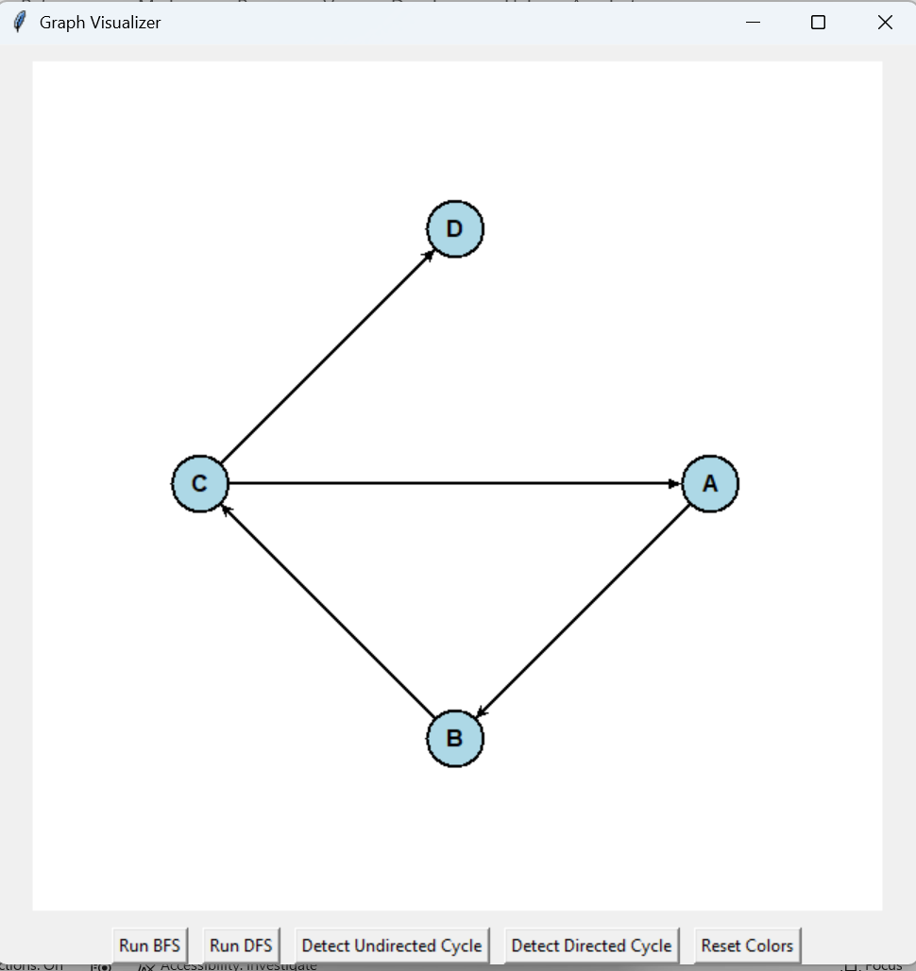
- Make a note of the results for Run BFS, Run BFS, Detect Undirected Cycle, Detect Directed Cycle and Reset Colors button presses.
- You will notice that one of the button (Detected Undirected Cycle ) button does not work.
- The challenge task for you is to fix this problem so that you can get both the detect undirected cycle and detect directed cycle button working in this app.
- The current starter template code allows :
  - Implements DFS recursion and cycle detection logic for directed graphs.
  - Allows you to practice visualization and UI updates.
  - Encourages thinking about recursion stacks for graph algorithms.
  - Builds on code you have already seen.
  - The starter code already implements directed cycle detection code and includes:
      - A button to trigger directed cycle detection.
      - Animated DFS recursion with recursion stack tracking.
      - Highlights vertices (yellow) and edges visited (orange) and those in the cycle (red).
      - Also provided Informative status messages in the UI, when cycle is detected.
  - What is missing in the starter code and what exactly needs to be implemented by you to complete this visualiser code for challenge task?
    - Update the code to make both directed and undirected cycle detection buttons working for the GraphVisualizer App
    - you need to be able to run the visualizer with two different graphs:
      - Undirected graph to test the undirected cycle detection button.
      - Directed graph to test the directed cycle detection button.
      - Because the visualizer depends on the structure of the graph passed into it, you can:
        - Create and run the app with an undirected graph when you want to test undirected cycle detection.
        - Create and run the app with a directed graph when you want to test directed cycle detection.
      - Report the results of the completed task with updated code and testing screenshots below:

import tkinter as tk
import math
import time
import threading
from collections import defaultdict

class Graph:
def __init__(self, directed=False, weighted=False):
self.graph = defaultdict(list)
self.weights = {}
self.directed = directed
self.weighted = weighted

def add_vertex(self, v):
if v not in self.graph:
self.graph[v] = []

def add_edge(self, v1, v2, weight=0):
if v1 in self.graph and v2 in self.graph:
self.graph[v1].append(v2)
if self.weighted:
self.weights[(v1, v2)] = weight

if not self.directed:
self.graph[v2].append(v1)
if self.weighted:
self.weights[(v2, v1)] = weight

class GraphVisualizer(tk.Tk):
def __init__(self, directed_graph, undirected_graph):
super().__init__()
self.title("Graph Visualizer")
self.geometry('700x700')

# Store both graphs
self.directed_graph = directed_graph
self.undirected_graph = undirected_graph

# Default graph
self.graph = self.undirected_graph

# Canvas
self.canvas = tk.Canvas(self, width=600, height=600, bg='white')
self.canvas.pack(pady=10)

self.vertex_positions = {}
self.vertex_circles = {}
self.edge_lines = {}

self.node_radius = 20
self.spacing = 200
self.center = (300, 300)

control_frame = tk.Frame(self)
control_frame.pack()

tk.Button(control_frame, text="Use Undirected Graph",
command=self.use_undirected_graph).pack(side=tk.LEFT, padx=5)

tk.Button(control_frame, text="Use Directed Graph",
command=self.use_directed_graph).pack(side=tk.LEFT, padx=5)

tk.Button(control_frame, text="Run BFS",
command=lambda: self.run_traversal("bfs")).pack(side=tk.LEFT, padx=5)

tk.Button(control_frame, text="Run DFS",
command=lambda: self.run_traversal("dfs")).pack(side=tk.LEFT, padx=5)

tk.Button(control_frame, text="Detect Undirected Cycle",
command=self.run_cycle_detection).pack(side=tk.LEFT, padx=5)

tk.Button(control_frame, text="Detect Directed Cycle",
command=self.run_directed_cycle_detection).pack(side=tk.LEFT, padx=5)

tk.Button(control_frame, text="Reset",
command=self.reset_colors).pack(side=tk.LEFT, padx=5)

self.info_label = tk.Label(self, text="")
self.info_label.pack(pady=5)

self.draw_graph()

def use_undirected_graph(self):
self.graph = self.undirected_graph
self.reset_colors()
self.draw_graph()
self.info_label.config(text="Switched to UNDIRECTED graph")

def use_directed_graph(self):
self.graph = self.directed_graph
self.reset_colors()
self.draw_graph()
self.info_label.config(text="Switched to DIRECTED graph")

def draw_graph(self):
self.canvas.delete("all")
self.vertex_positions.clear()
self.vertex_circles.clear()
self.edge_lines.clear()

vertices = list(self.graph.graph.keys())
n = len(vertices)
if n == 0:
return

angle_gap = 360 / n
cx, cy = self.center

# Draw vertices
for i, v in enumerate(vertices):
angle = i * angle_gap
x = cx + self.spacing * math.cos(math.radians(angle))
y = cy + self.spacing * math.sin(math.radians(angle))

self.vertex_positions[v] = (x, y)

circle = self.canvas.create_oval(
x - self.node_radius, y - self.node_radius,
x + self.node_radius, y + self.node_radius,
fill='lightblue'
)
self.vertex_circles[v] = circle

self.canvas.create_text(x, y, text=v)

# Draw edges
for v in vertices:
x1, y1 = self.vertex_positions[v]
for nbr in self.graph.graph[v]:
x2, y2 = self.vertex_positions[nbr]

if self.graph.directed:
line = self.canvas.create_line(x1, y1, x2, y2, arrow=tk.LAST, width=2)
else:
line = self.canvas.create_line(x1, y1, x2, y2, width=2)

self.edge_lines[(v, nbr)] = line

def reset_colors(self):
for circle in self.vertex_circles.values():
self.canvas.itemconfig(circle, fill='lightblue')

for edge in self.edge_lines.values():
self.canvas.itemconfig(edge, fill='black', width=2)

self.info_label.config(text="")

def highlight_vertex(self, v, color):
if v in self.vertex_circles:
self.canvas.itemconfig(self.vertex_circles[v], fill=color)
self.update()

def highlight_edge(self, v1, v2, color):
if (v1, v2) in self.edge_lines:
self.canvas.itemconfig(self.edge_lines[(v1, v2)], fill=color, width=3)
self.update()

def run_traversal(self, method):
def worker():
self.reset_colors()
visited = set()
start = next(iter(self.graph.graph))

if method == "bfs":
queue = [start]
while queue:
v = queue.pop(0)
if v not in visited:
self.highlight_vertex(v, 'orange')
visited.add(v)
time.sleep(0.5)

for nbr in self.graph.graph[v]:
if nbr not in visited:
queue.append(nbr)
self.highlight_edge(v, nbr, 'green')

elif method == "dfs":
stack = [start]
while stack:
v = stack.pop()
if v not in visited:
self.highlight_vertex(v, 'purple')
visited.add(v)
time.sleep(0.5)

for nbr in self.graph.graph[v]:
if nbr not in visited:
stack.append(nbr)
self.highlight_edge(v, nbr, 'blue')

threading.Thread(target=worker, daemon=True).start()

def run_cycle_detection(self):
if self.graph.directed:
self.info_label.config(text="Switch to UNDIRECTED graph first")
return

visited = set()

def dfs(v, parent):
visited.add(v)
self.highlight_vertex(v, 'yellow')
time.sleep(0.5)

for nbr in self.graph.graph[v]:
if nbr not in visited:
self.highlight_edge(v, nbr, 'orange')
if dfs(nbr, v):
return True
elif nbr != parent:
self.highlight_vertex(v, 'red')
self.highlight_vertex(nbr, 'red')
self.highlight_edge(v, nbr, 'red')
return True
return False

for v in self.graph.graph:
if v not in visited:
if dfs(v, None):
self.info_label.config(text="Cycle detected (Undirected)")
return

self.info_label.config(text="No cycle found (Undirected)")

def run_directed_cycle_detection(self):
if not self.graph.directed:
self.info_label.config(text="Switch to DIRECTED graph first")
return

visited = set()
rec_stack = set()

def dfs(v):
visited.add(v)
rec_stack.add(v)

self.highlight_vertex(v, 'yellow')
time.sleep(0.5)

for nbr in self.graph.graph[v]:
if nbr not in visited:
self.highlight_edge(v, nbr, 'orange')
if dfs(nbr):
return True
elif nbr in rec_stack:
self.highlight_vertex(v, 'red')
self.highlight_vertex(nbr, 'red')
self.highlight_edge(v, nbr, 'red')
return True

rec_stack.remove(v)
return False

for v in self.graph.graph:
if v not in visited:
if dfs(v):
self.info_label.config(text="Cycle detected (Directed)")
return

self.info_label.config(text="No cycle found (Directed)")

if __name__ == "__main__":

# Undirected Graph
g_undirected = Graph(directed=False)
for v in ['A', 'B', 'C', 'D']:
g_undirected.add_vertex(v)

g_undirected.add_edge('A', 'B')
g_undirected.add_edge('B', 'C')
g_undirected.add_edge('C', 'A') # cycle
g_undirected.add_edge('C', 'D')

# Directed Graph
g_directed = Graph(directed=True)
for v in ['A', 'B', 'C', 'D']:
g_directed.add_vertex(v)

g_directed.add_edge('A', 'B')
g_directed.add_edge('B', 'C')
g_directed.add_edge('C', 'A') # cycle
g_directed.add_edge('C', 'D')

app = GraphVisualizer(g_directed, g_undirected)
app.mainloop()
(code in github folder: graph_directed_undirected_visualiser.py)

